
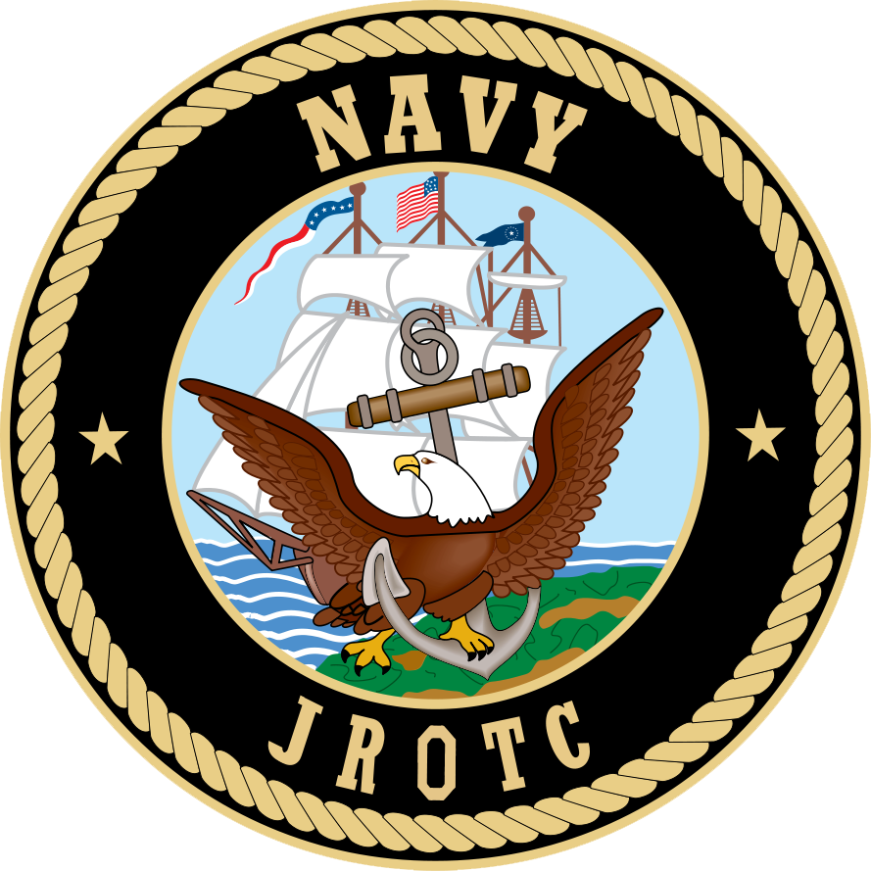
PARENT/TEACHER APPROVAL FOR FIELD TRIP

Teacher: LtCol Lyon / Chief Rodrigues Program: NJROTC
Trip Date: Thursday, March 23, 2017
Destination: Appalachian Trail – Harpers Ferry, WV to Gaithland, Park, MD

Field Trip Objective: All NJROTC cadets are welcome to join us for a 10 mile hike on the A.T. to promote fitness while utilizing map and compass.

Departure Time: 0745 Approximate Return Time: 1400

REQUIRED:
- Cost: $0.00 (Picnic type lunch provided by boosters at finish)
- ALL cadet forms (school physical, health risk questionnaire, and waiver) and $25 unit maintenance fee must be submitted.
- Cadets should wear clothing appropriate for the weather and hiking the trail. (Appropriate footwear!!)
- Muster at 0730 inside of the NJROTC classroom at T.J.
- The first 40 cadets to return this form to Chief Rodrigues will be added to the list. If we have enough to fill a second bus (minimum of 25), we will make an announcement.
- Deadline to register: Thursday, March 16th by 1430.

Student Name:_____________________________________________________
Print
I give permission for this student to go on the stated field trip.

Parent/Guardian Signature _______________________ Date:________

Parent telephone number in case of emergency: ___________________

TEACHERS’ SIGNARURES: Signature implies passing grades and consent to miss a day of school. Advance assignments should be provided.

Period 1 _________________ Period 3 ___________________

Period 2 ____________________ Period 4 _______________________

