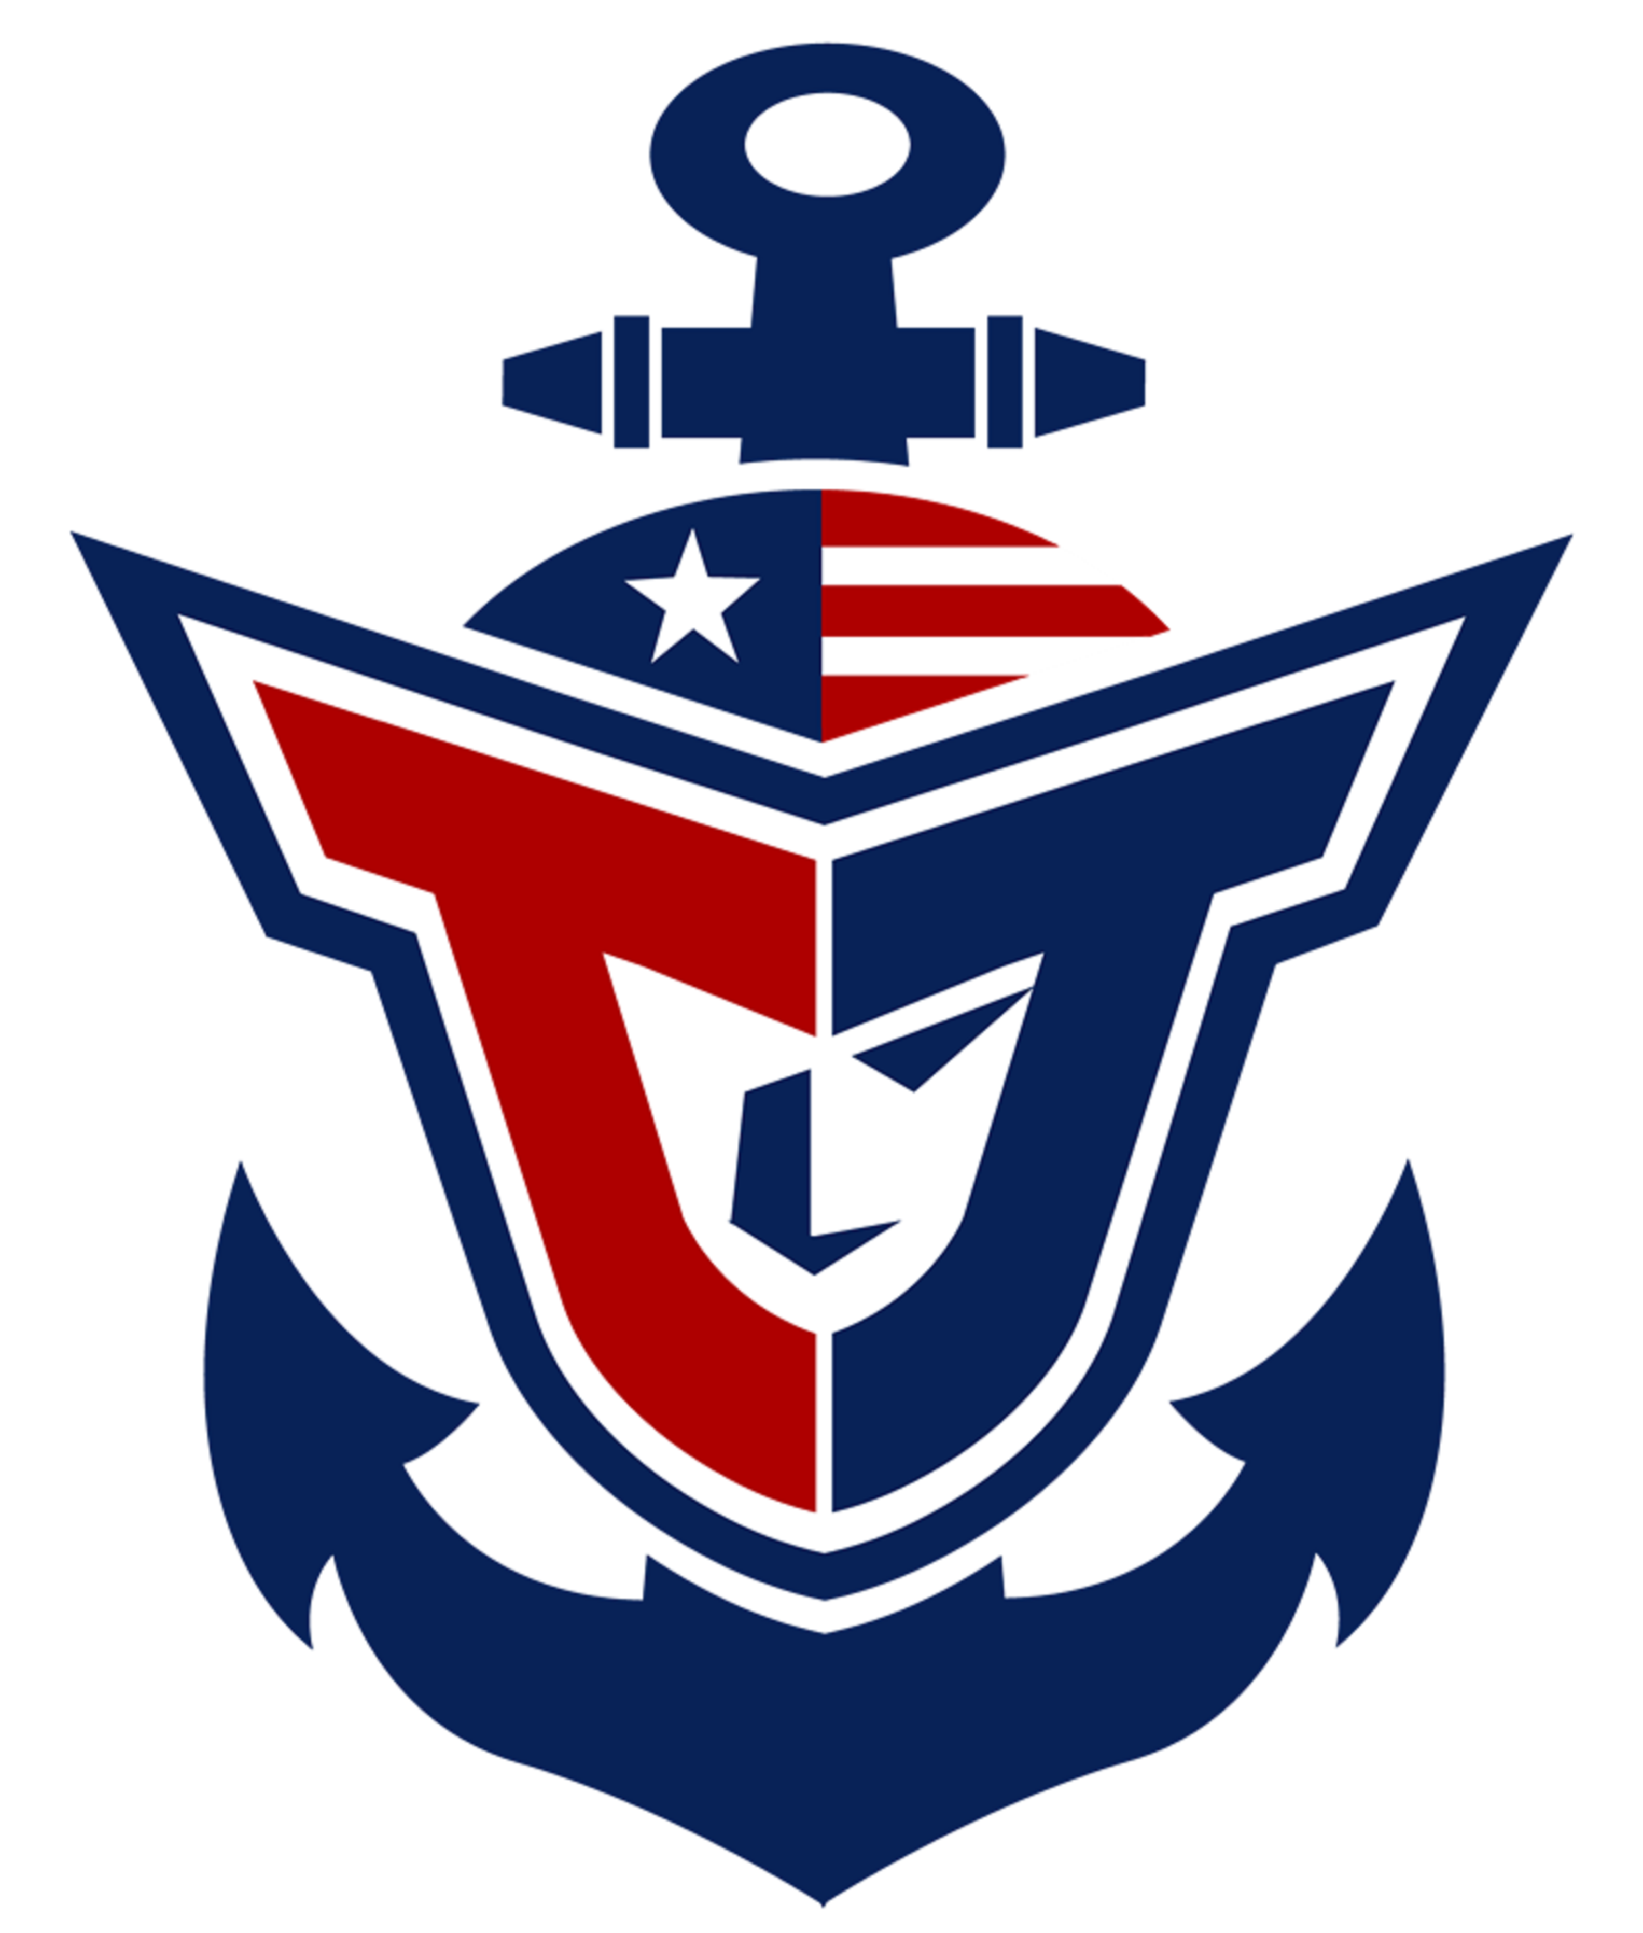
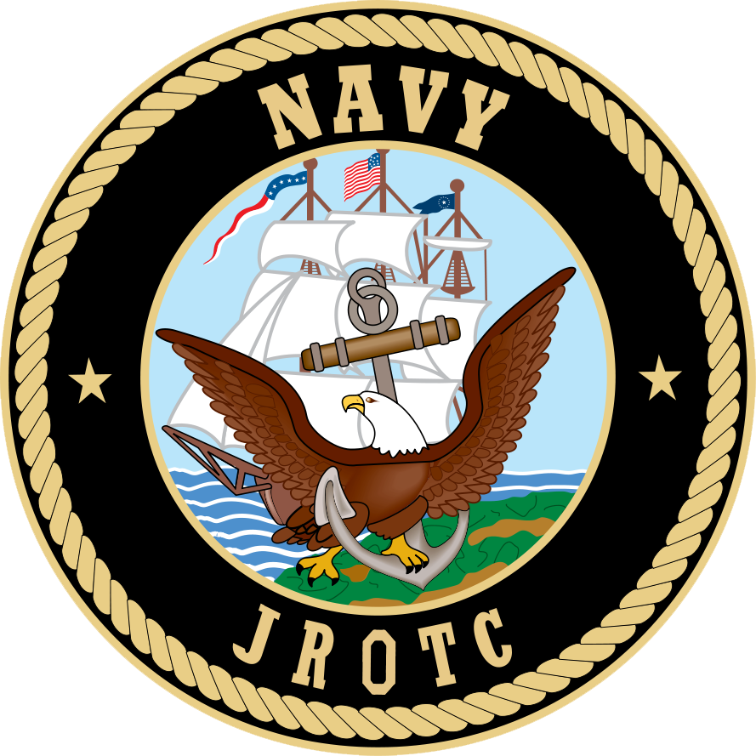
PARENT/TEACHER APPROVAL FOR FIELD TRIP

Teacher: LtCol Lyon / Chief Rodrigues Program: NJROTC
Trip Date: September 27, 2016 Destination: U.S. Naval Academy

Field Trip Objective: Naval Academy campus tour, YP boat ride and run the obstacle course

Departure Time: 0630 Approximate Return Time: 1400

Cost: $7.00 for lunch. (Will have food pre-ordered)

- ALL cadet forms (school physical, health risk questionnaire and waiver) and $25 unit maintenance fee must be submitted.
- Cadets will wear the Navy Service Uniform and change into unit P.T. gear prior to the obstacle course. (If issued)
- Muster at 0630 outside of main office. Bus departs at 0645
- The first 40 cadets to return this form and the $7.00 to Chief Rodrigues will be added to the list. If we have enough to fill a second bus (minimum of 25), we will make an announcement.

Student Name:_____________________________________________________
Print
I give permission for this student to go on the stated field trip.

Parent/Guardian Signature _______________________ Date:________

Parent telephone number in case of emergency: ___________________

TEACHERS’ SIGNARURES

Signature implies passing grades and consent to miss a day of school. Advance assignments should be provided.

Period 1 _________________ Period 3 ___________________

Period 2 ____________________ Period 4 _______________________

