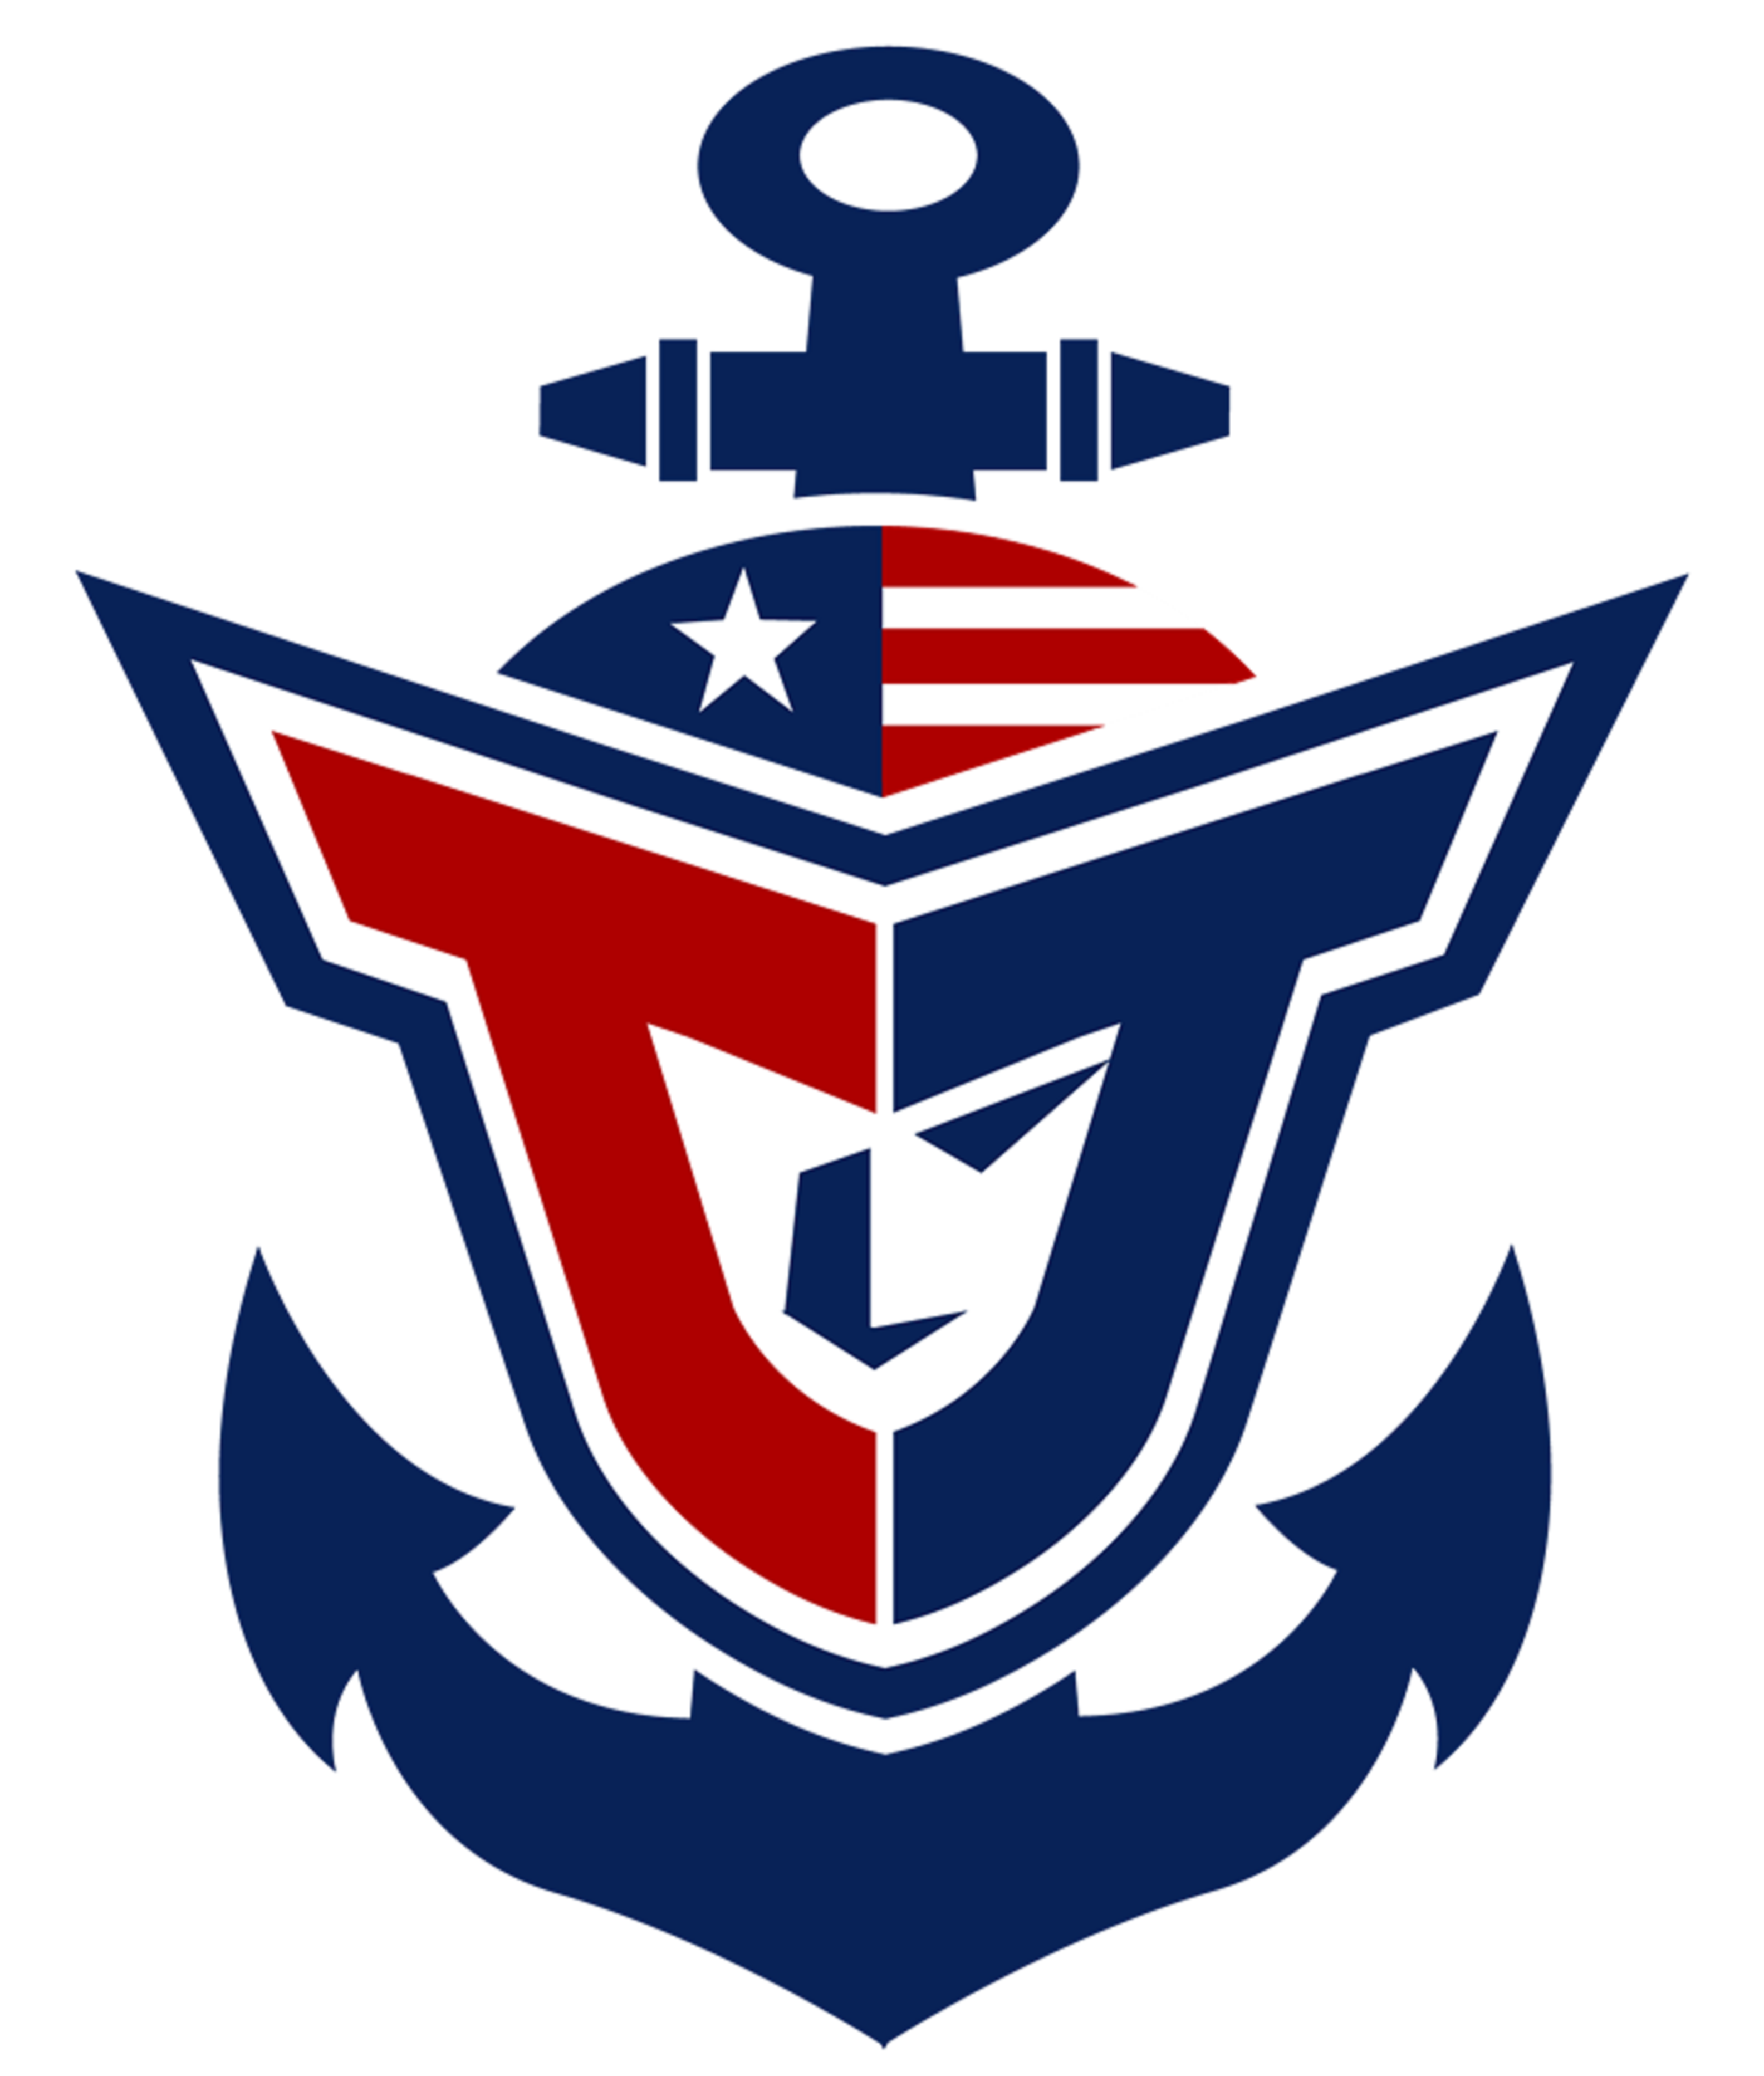
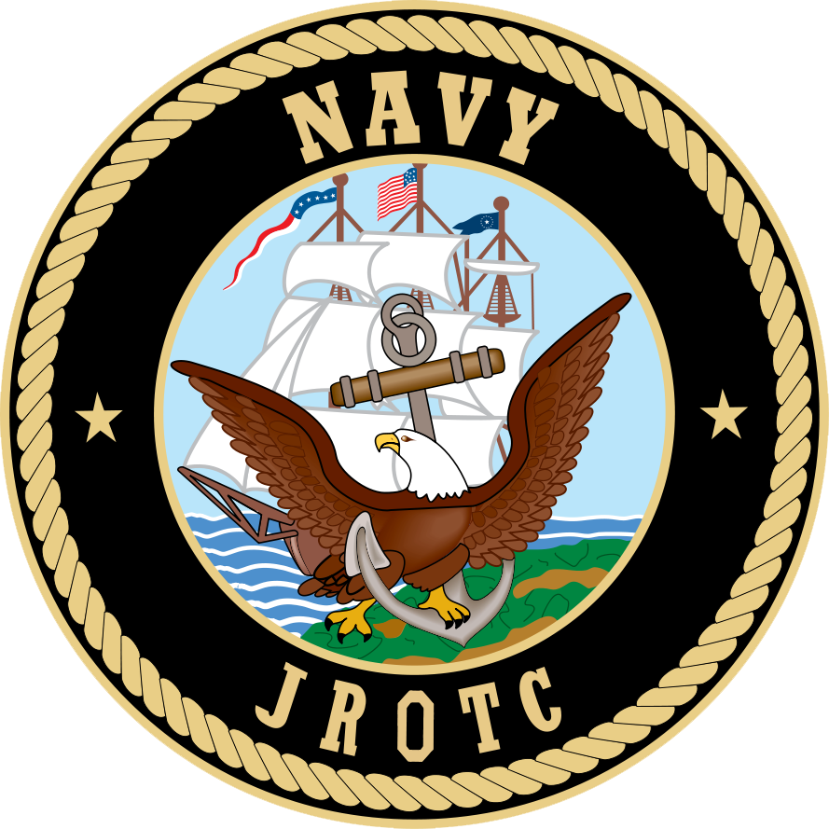
PARENT/TEACHER APPROVAL FOR FIELD TRIP

Teacher: LtCol Lyon / Chief Rodrigues Program: NJROTC
Trip Date: Thursday, February 23, 2017
Destination: Gettysburg National Military Park, Pennsylvania

Field Trip Objective: All NJROTC cadets are welcome to join us for an orientation trip to the Gettysburg museum and battlefield. This trip will include museum admission, an orientation movie and a 2 hour guided tour of the battlefields.

Departure Time: 0745 Approximate Return Time: 1400

REQUIRED:
- Cost: $0.00 (Bring a bag lunch or money for food at museum)
- ALL cadet forms (school physical, health risk questionnaire and waiver) and $25 unit maintenance fee must be submitted.
- Cadets should wear clothing appropriate for the weather as we will have frequent stops along the battlefield tour. Uniform NOT required.
- Muster at 0730 inside of the NJROTC classroom at T.J.
- The first 42 cadets to return this form (hand deliver or e-mail) to Chief Rodrigues will be added to the list. If we have enough to fill a second bus (minimum of 25), one will be reserved. 84 total seats available for this trip.
- Deadline to register: Thursday, February 9th by 1430.

Student Name:_____________________________________________________
Print
I give permission for this student to go on the stated field trip.

Parent/Guardian Signature _______________________ Date:________

Parent telephone number in case of emergency: ___________________

TEACHERS’ SIGNARURES: Signature implies passing grades and consent to miss a day of school. Advance assignments should be provided.

Period 1 _________________ Period 3 ___________________

Period 2 ____________________ Period 4 _______________________

